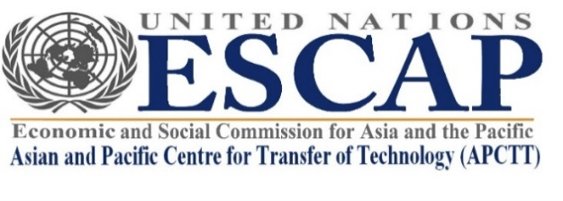
NOMINATION FORM

- International Conference on Fourth Industrial Revolution Technologies for Sustainable Development, New Delhi, India, 30 November 2021 (virtual)

- The Seventeenth Session of the Governing Council of APCTT, New Delhi, India, 1-2 December 2021 (virtual)

(Due to COVID-19 pandemic, arrangements will be made for member State representatives and international speakers to join through virtual platforms and participate in the Governing Council session and the International Conference.)

Please print or write legibly full details, including e-mail and send the completed form as early as possible preferably by 5 November 2021. Please send form to: head.apctt@un.org with copy to dasm@un.org and sahus@un.org.

1. Name | ______________________________________________  First Middle Last
2. Nationality

- Gender
4. Functional title

5. Organization

6. Nomination | Are you an official delegate representing your country to the Governing Council? Yes / No  Are you going to make a presentation during the panel discussion session of International Conference on 30 November? Yes / No
7. Functional area | Science, technology and innovation policy  New and emerging technologies  for sustainable development  Technology Transfer | Intellectual property rights  Regional technology cooperation  Other……………..
8. Contact details
Telephone: Country code: ______ City code: ______ Number: _______________
E-mail:
9. Events
I would like to participate in the following events (check all that apply):
International Conference on Fourth Industrial Revolution Technologies for Sustainable Development, New Delhi, India, 30 November 2021

The Seventeenth Session of the APCTT Governing Council, 1-2 December 2021

Approved by:

……………………………………………….. …………………………………………….
Name and designation of Head of Institution Signature and official stamp

For more information, kindly email: dasm@un.org with copy to: sahus@un.org

